Lead is created > Leads are pooled into one basket >

Once a profile is upgraded then it becomes SPP (partner) - $500 + 10% GST
They should be able to view the leads list.

Since the SPP has taken basic subscription. He/she will be able to view the leads and select leads accordingly (They will be able to see the contact details). Once they Once they reach 10 for a month, they will ask to pay additional amount for each new leads contact details which is around $250 per lead+ GST. If the SPP does not convert within 7 days (which can be changed by the business admin as delegated rule) then it goes back to the main pool where it will be displayed other SPP. There will be prompt in 3 business days to convert the lead else it will be sent to the main pool. Once they opt for converted then X amount will be deducted from the SPP account.

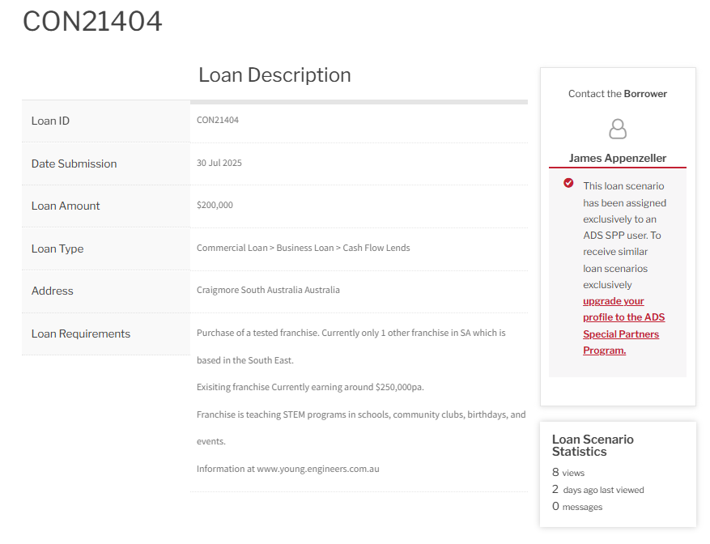
Once SPP view the contact detail. It is put into their pool for x days

